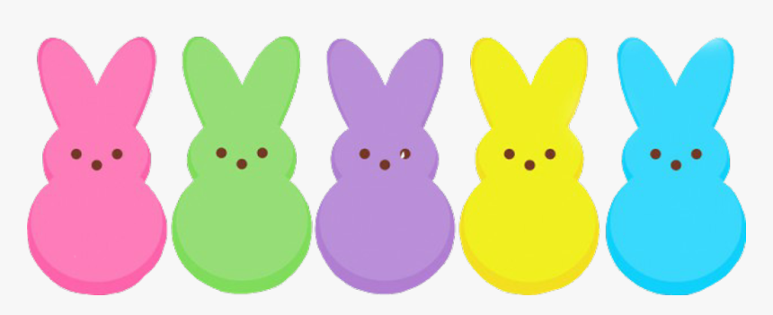
 | April 2026
Sun | Mon | Tue | Wed | Thu | Fri | Sat
 |  |  | 1 | 2  Yoga  9:00 am | 3 | 4  Easter Egg Hunt  10:00
5  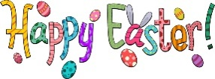 | 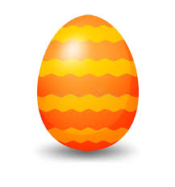  6 | 7  Lunch 11:30 | 8 | 9  Yoga  9:00 am | 10  Art in April  12:00 – 6:00 pm  City office | 11  Art in April  12:00 – 6:00 pm  City office
12 | 13 | 14  Lunch 11:30 |   15 | 16 Yoga  9:00 am  City Council  6:00 pm | 17 | 18
19 | 20 | 21  Lunch 11:30  Planning Commission  7:00 pm | 22 | 23  Yoga  9:00 am | 24 | 25  Spring  Cleean Up  Dumpsters at the parks
26  Spring  Cleean Up  Dumpsters at the parks | 27 | 28  Lunch 11:30 | 29 | 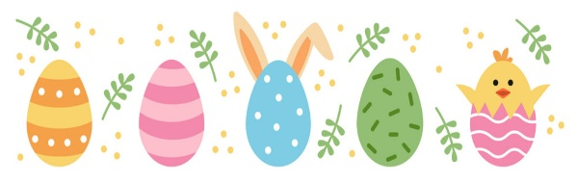  30  Yoga  9:00 am

