Art in April
6th Annual Marriott Slaterville City Art Show
12 Noon to 6:00 PM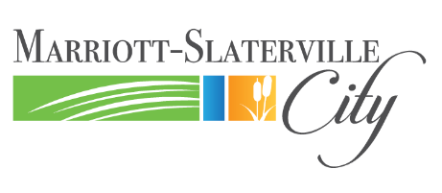 April 12-13, 2024
Marriott-Slaterville Municipal Complex
Visit, enjoy and appreciate the talents of Marriott-Slaterville artists from all types of media; admission is free of charge, and you will be amazed at the exceptional works completed by people within the community. Open to all residents, church or school goers, and business staff in Marriott-Slaterville.
Categories:
1. Oils
2. Acrylics and Watercolor
3. Pen, Pencil, and Ink
4. Photography or Computer Design
5. Sculptural, Clay, Stone, Woodwork
6. Textile or 3D Printing
7. Lego (3’x3’x3’ size limit)
8. Metal
9. Musical Arts
To enter your work, fill out the form, below the line, detach it and bring the work to the Marriott-Slaterville City Office during office hours on or before Thursday, April 11, at 4:00 PM. Volunteers will set up the displays for the show. Art may be picked up after Monday, April 15, by 4:00 PM at the City Office. One form per work, limit of five (5) submissions.
_________________________________________________________________________________________________

Art in April
5th Annual Marriott Slaterville City Art Show Application
1570 West 400 North
Marriott-Slaterville City, Utah

Artist______________________________
Category__________________________
Name of piece______________________
Owner of piece_____________________
Sale price__________________________
Any sale must be conducted privately between art owner/creator and purchaser, after show is completed.

Name________________________________________Adress_____________________________________________________________________________________
Email address_________________________________
Cell number_____________________________
Best time to contact______________________
Brief description of your piece _______________________________________________________________________________________________________________________________________

By entering my art, I understand that I release Marriott-Slaterville and all officers, volunteers and associates from any and all liability and that I similarly release and hold harmless any and all patrons should any damage occur to my work. I understand that every precaution will be taken by the City to protect my work and that my art will be properly secured until it is released back to me at the end of the show.
Signed________________________________________
Printed name__________________________________
Date__________________________________________

