November
2023
Sunday | Monday | Tuesday | Wednesday | Thursday | Friday | Saturday
 |  |  | 1 | 2 | 3 | 4
 |  |  |  | Yoga  9:00 am | Veteran’s Dinner  6:00-7:30  Jeremiah’s
5 | 6 | 7 | 8 | 9 | 10 | 11
 |  | Senior Lunch 11:30 |  | Yoga  9:00 am
12 | 13 | 14 | 15 | 16 | 17 | 18
 |  | Senior Lunch 11:30 |  | Yoga  9:00 am | Holiday Craft Fair  Nov 17-18  10:00 am – 3:30 PM | 
19 | 20 | 21 | 22 | 23 | 24 | 25
 |  | Senior Lunch 11:30 | City Office  Opened 9:00 – 1:00 | 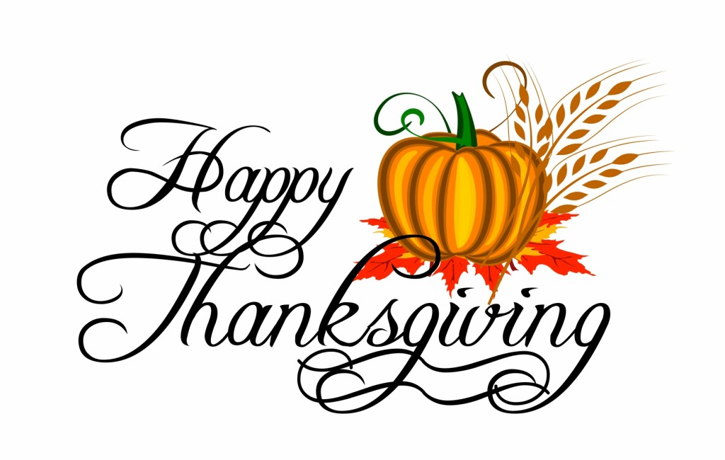
26 | 27 | 28 | 29 | 30
 |  | Senior Lunch 11:30 |  | Yoga  9:00 am |  | Breakfast with Santa  Saturday Dec 9th  9:00 – 11:00 am
 |  |  |  |  | 
RSVP City Office
801-627-1919
Space limited

