September |  |  |  | 
 |  |  |  | 2023
Sunday | Monday | Tuesday | Wednesday |  | Thursday | Friday | Saturday
 |  |  |  |  |  | 1 | 2
3 | 4 | 5 | 6 |  | 7 | 8 | 9
 |  | Senior Lunch 11:30 |  |  | Yoga  9:00 am
10 | 11 | 12 | 13 |  | 14 | 15 | 16
 |  | Senior Lunch 11:30 |  |  | Yoga  9:00 am |  | Family Night Dinner  5:30 – 8:00  City Municipal Complex
17 | 18 | 19 | 20 |  | 21 | 22 | 23
 |  | Senior Lunch 11:30 |  |  | Yoga  9:00 am
24 | 25 | 26 | 27 |  | 28 | 29 | 30
 |  | Senior Lunch 11:30  Flu Shot Clinic  11:00-12:30 |  |  | Yoga  9:00 am | 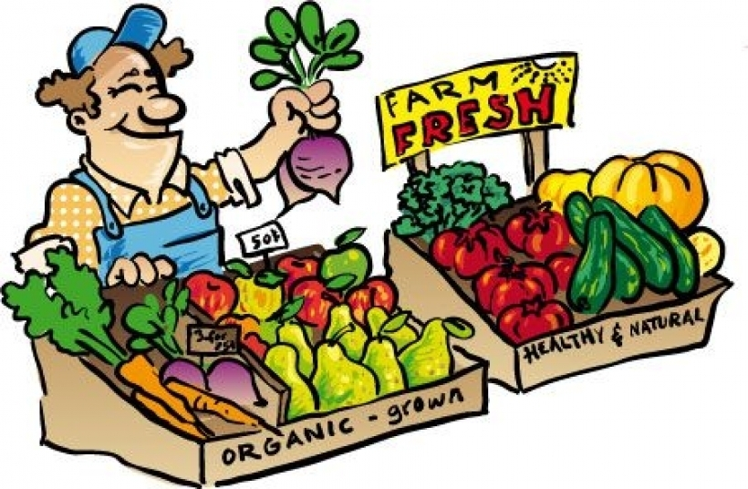 | Garden Market  September  9,16,23,30

