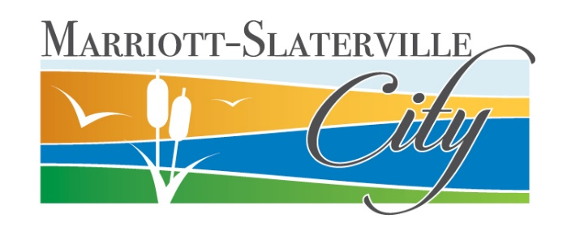

Privacy Statement

General
Marriott-Slaterville City (hereafter “City”) respects the privacy of every individual who visits our websites. This Privacy Statement outlines the information the City will collect and how the City will use that information.

Personally Identifiable Information
When you visit City websites, the City does not collect any personally identifiable information about you (such as your name, address, telephone number, social security number, or e-mail address) unless you provide it to the City voluntarily.
The City may request personally identifiable information from you in order to provide the requested service. Once collected the information may be stored indefinitely electronically.
If you desire to not provide any Personally Identifiable Information on City websites, you may contact the City to utilize the services by non-electronic methods.
The information the City may collect electronically includes, but is not limited to:
- First and Last names
- Physical address
- Email address
- Telephone number
- Payment information related to credit cards and bank account transactions with the City
- Social Security Number
- Parcel Number
- Birth Date
- Origin of Birth

Use of Personally Identifiable Information
All of these matters and other information may be lawfully classified as Private or Controlled in accordance with the Government Records Access and Management Act (GRAMA). The City may store and process your personally identifiable information to better understand your needs and how we may improve our electronic services and we may use your personally identifiable information to contact you if requested by you (for example, we may send you a questionnaire or we may respond to your comments or requests for information).
The City does not give your personally identifiable information to any outside organization unless required by law.

Non-Personally Identifiable Information
The City may collect information about you that is not personally identifiable. Examples of this type of information include IP address, time of visit, the type of internet browser or computer operating system you are using, and the domain name of the website from which you linked to our sites. The City may use this information to help diagnose problems with our server and to administer City websites. It may also be used to gather broad demographic information about users in general. This information does not contain anything that can identify users personally.
Additionally, the City may store some information on your computer. This information will be in the form of a "cookie". Most internet browsers enable you to erase cookies from your computer hard drive, block all cookies, or receive a warning before a cookie is stored. Please refer to your browser instructions or help screen to learn more about these functions.
The City will not attempt to tie any personally identifiable information on individual users to non-personally identifiable information.

Security
The City is committed to keeping secure the data you provide to the City and will take reasonable precautions to protect your personally identifiable information from loss, misuse, or alteration. The City employs industry standards in securing this information.

Third-party and Non-City Websites
The City may use third parties to assist with the City website. The City may provide links to non-City websites. The City is not responsible for the content or the privacy policies of third parties and non-City websites links. The City recommends that visitors to non-City sites check the privacy statements of these sites and be cautious about providing personally identifiable information without a clear understanding of how the information will be used.
Visitors may also wish to consult privacy guidelines such as those recommended by the Online Privacy Alliance.
Contact for Personally Identifiable Information
If you have submitted personally identifiable information through a City website or if someone else has submitted your personally identifiable information through a City website, and you would like to have that information deleted from our databases, please contact the City.

